#. html css simple calendar without functionality
#. How TO - Flip Card
#. visual studio see two files in comparing mode

#. html css simple calendar without functionality
In https://www.w3schools.com/howto/tryit.asp?filename=tryhow_css_calendar
Website media screen width given as

13.1%,12.5%,12.2%
I changed it to
13.1%,10.5%,8.1%
Above

Page became unresopnsive with it
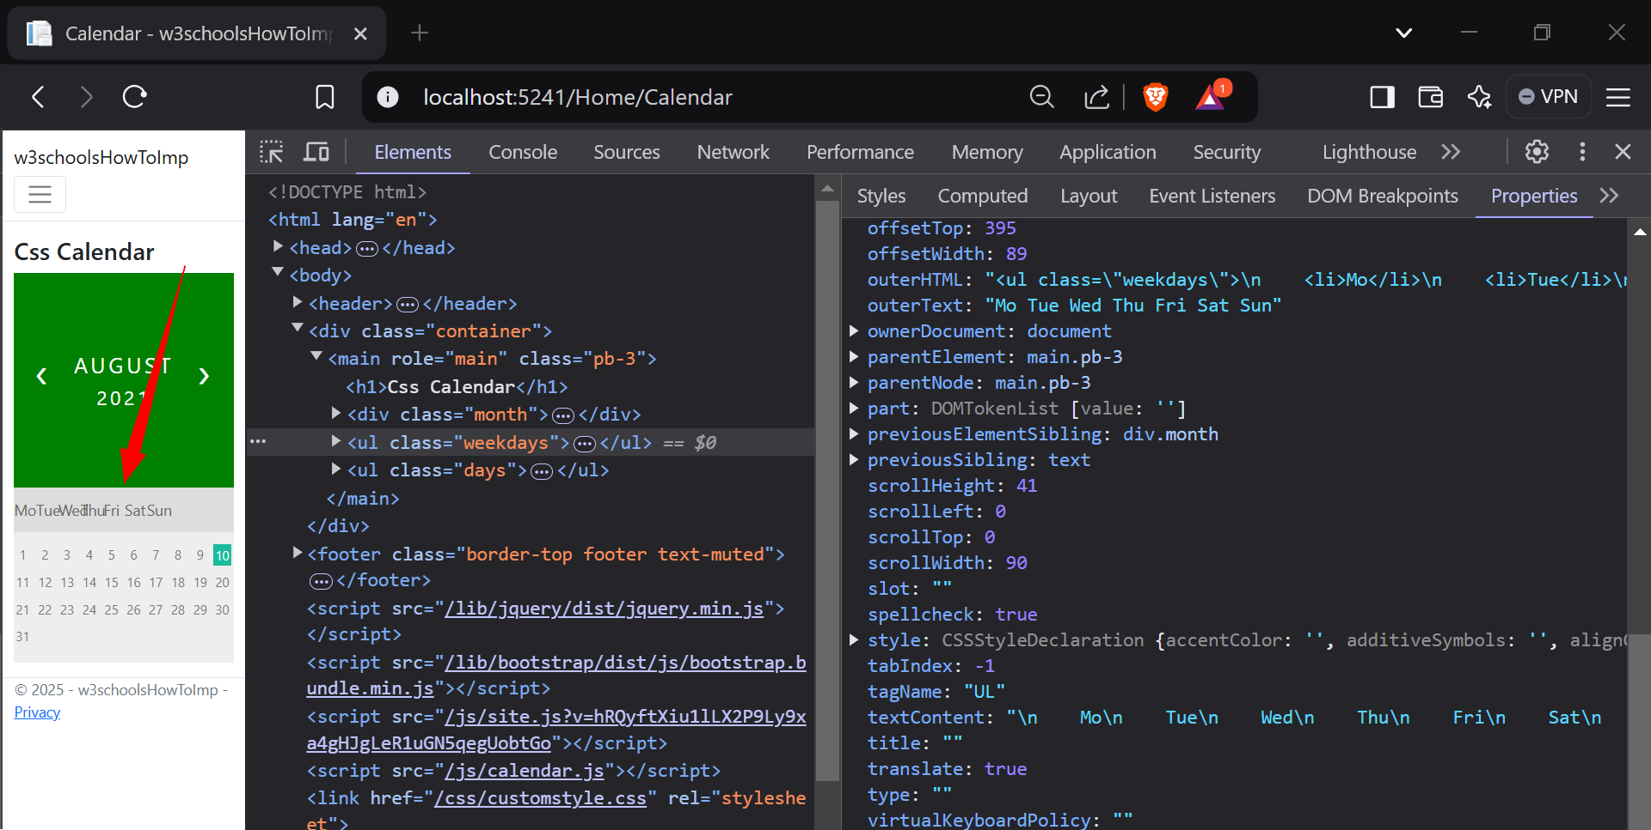
Days alignment is removed
It’s important when I changed back to w3schools style page became responsive even with min screen

#. visual studio see two files in comparing mode
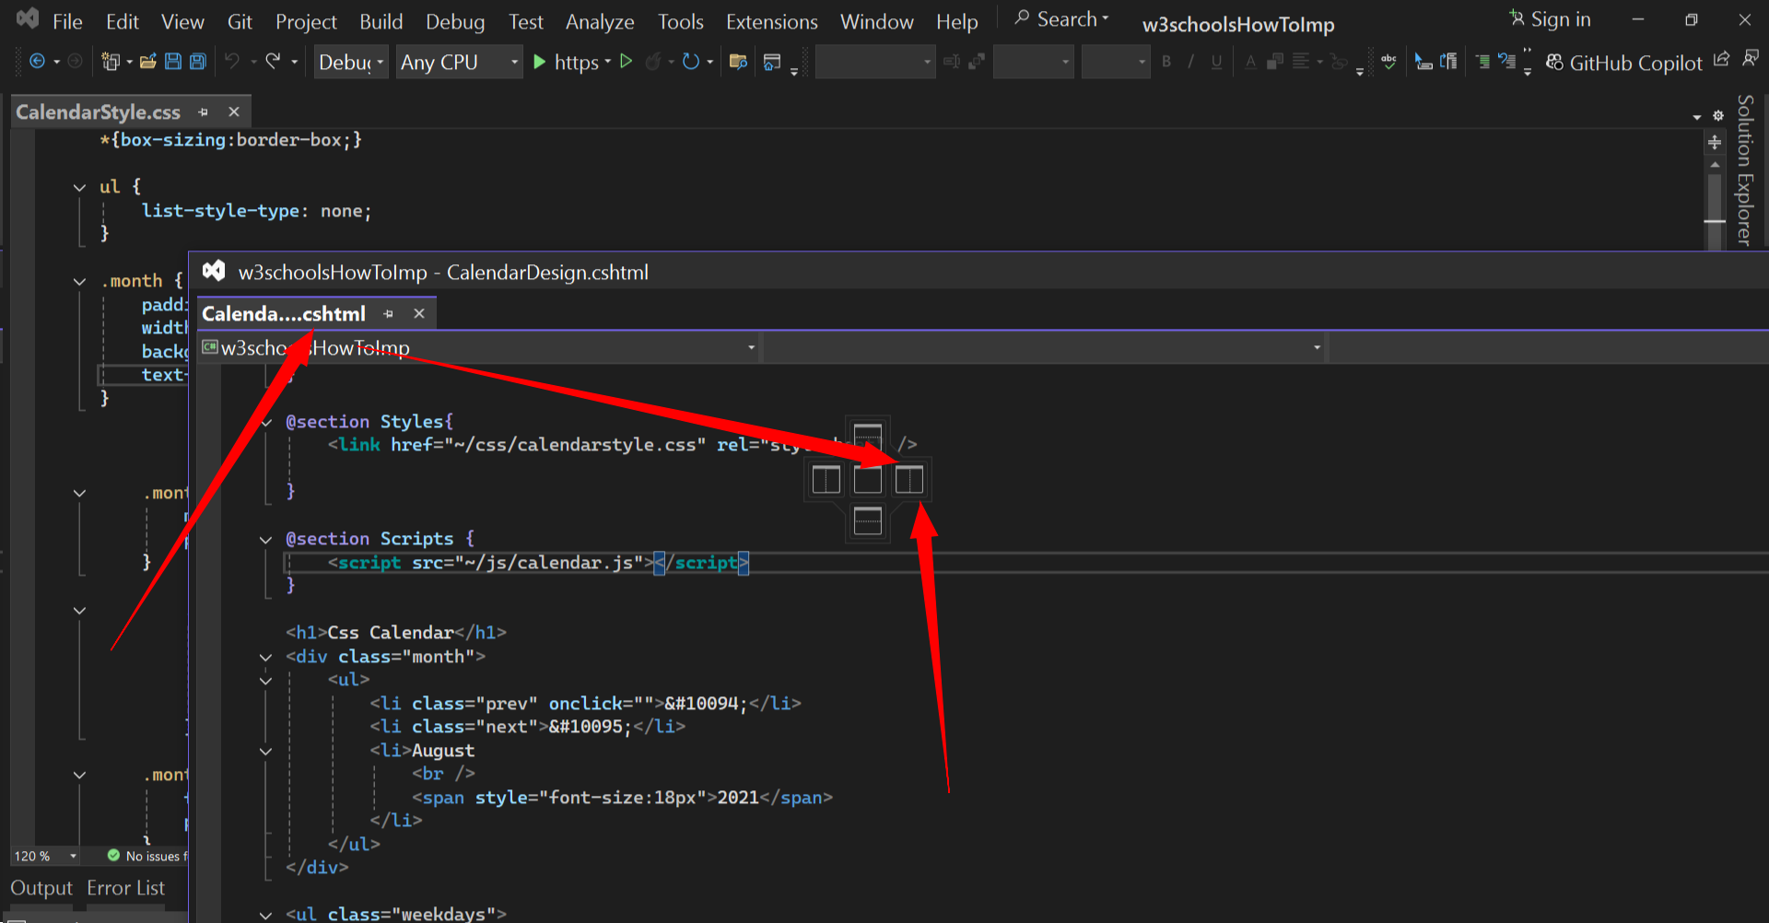drag and hover on right box that time you see 2 files in comparing way
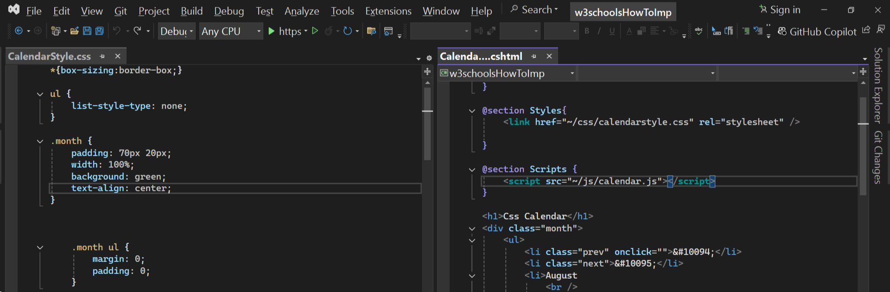
Like above

